**Database Description**

High level summary and four main parts of the ME Database

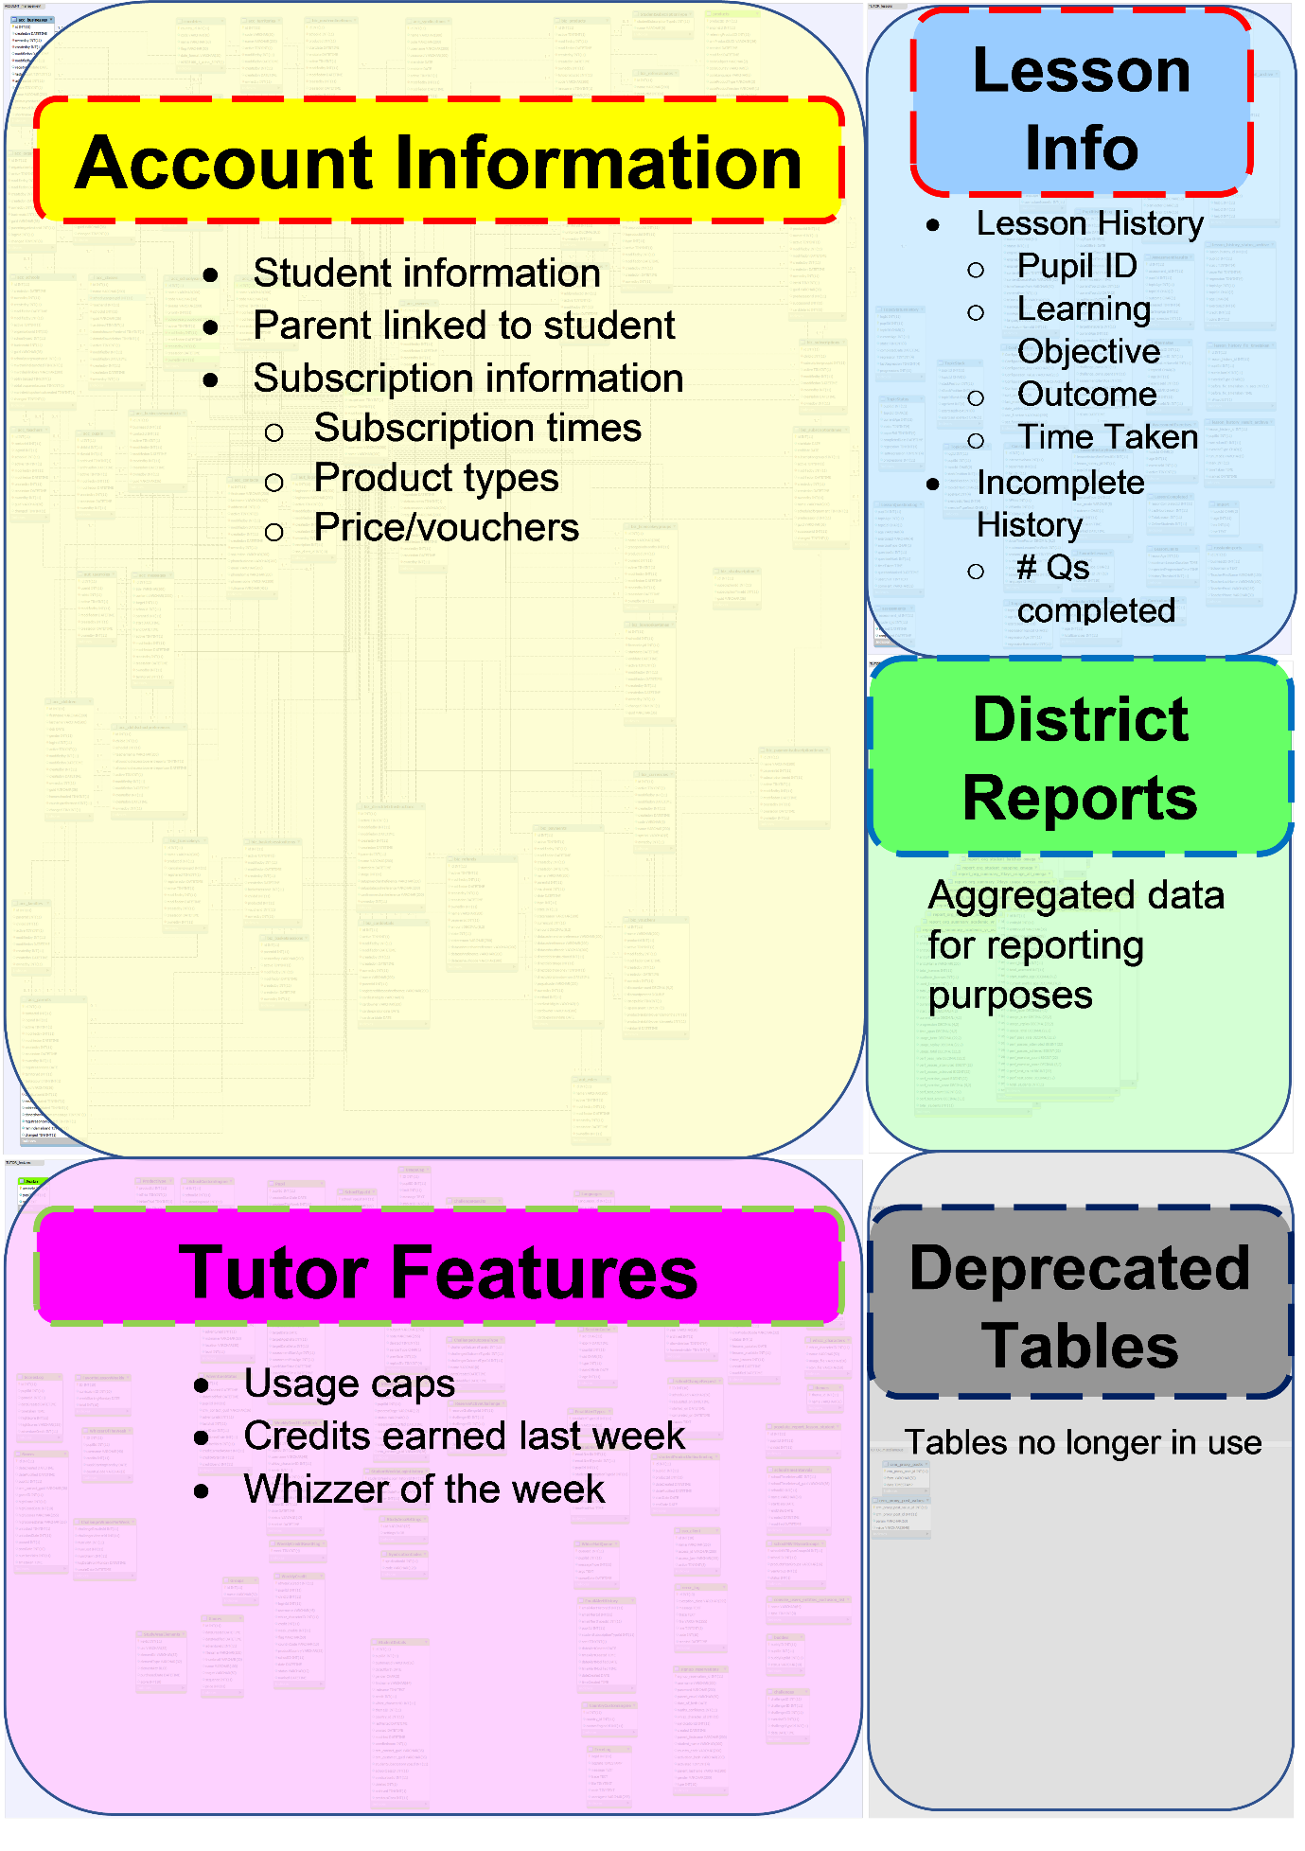

**Data points we capture, and structure of our relational database**

**Complete Lesson History:**

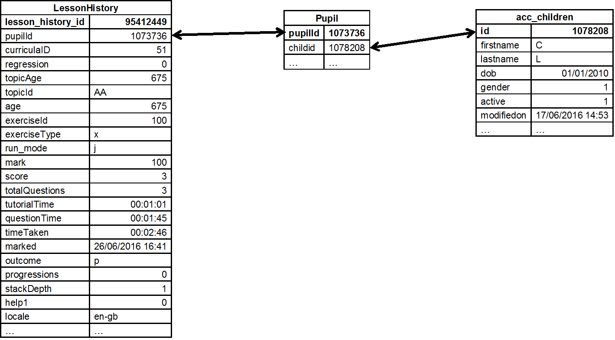

**Incomplete Lesson History**

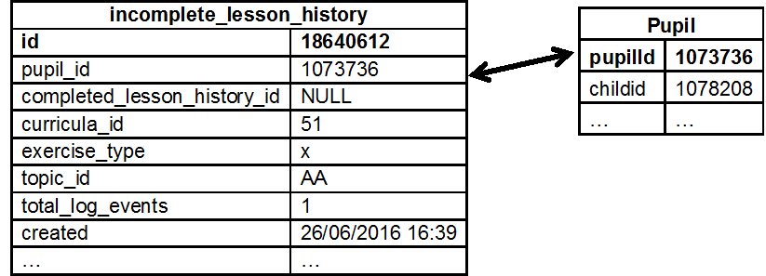

**Retention Curves**

**Graphs of # cancellations against time after purchase**

1. Monthly users



1. Annual users



**KPIs – retention rates**

**Monthly users**



**Annual Users**



**Average Weekly Usage before subscribers cancel**

1. Monthly Users (< 30 weeks before cancellation)



1. Annual Users (< 52 weeks before cancellation)

